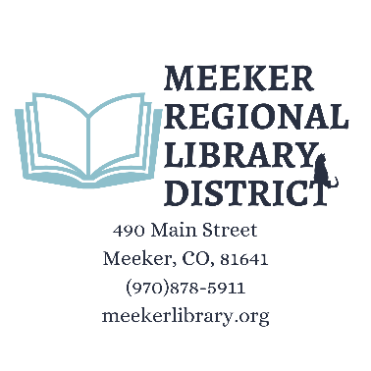
July 21, 2026 Board Workshop
6pm-7pm
Meeting will be held in Blue Spruce Room at Town Hall
The Meeker Regional Library District exists solely to enhance the quality of each individual library user by upholding to the Library Bill of Rights, the Freedom to Read, Patron Privacy, Art in the Library and other statements included in this document.
The Library recognizes and appreciates its status as the only free and inclusive cultural and educational institution with the community and endeavor to continually expand the opportunities we make available to our patrons. We will strive to mitigate, if not overcome, the limitations our community's geographic situation places on our informational, educational and recreational choices by exploring advances in telecommunication technology as well as by more traditional means of library service.
The Workshop is open to the public. No action will be taken.
1. Call meeting to order
2. Pledge of Allegiance
3. Discussion Items
- Discuss IGA re Trustee application process with Town of Meeker Board and RBC Board of Commissioners.
4. Board Member Comments

